EXPERIMENT NO: 02

NAME : THAKUR ATIF UMAR
ROLL NO: 14DCO69
BATCH : 02

AIM : To Implement Breadth First Search (BFS) and Depth First Search (DFS) Algorithm.

# CODE FOR BREADTH FIRST SEARCH :

import java.util.InputMismatchException;
import java.util.LinkedList;
import java.util.Queue;
import java.util.Scanner;
public class BFS
{
private Queue<Integer> queue;
static int flag;
public static int goal;
public BFS()
{
queue = new LinkedList<Integer>();
}
public void bfs(int adjacency_matrix[][], int source,int goal)
{
int number_of_nodes = adjacency_matrix[source].length - 1;
int g=goal;
int[] visited = new int[number_of_nodes + 1];
int i, element;
visited[source] = 1;
queue.add(source);
while (!queue.isEmpty())
{
element = queue.remove();
i = element;
if(i == g)
{
flag=1;
}
System.out.print(i + "\t");
while (i <= number_of_nodes)
{
if (adjacency_matrix[element][i] == 1 && visited[i] == 0)
{
queue.add(i);
visited[i] = 1;
}
I++;
}
}
}

public static void main(String... arg)
{
int number_no_nodes, source;
Scanner scanner = null;
try
{
System.out.println("Enter the number of nodes in the graph");
scanner = new Scanner(System.in);
number_no_nodes = scanner.nextInt();
int adjacency_matrix[][] = new int[number_no_nodes + 1][number_no_nodes + 1];
System.out.println("Enter the adjacency matrix");

for (int i = 1; i <=number_no_nodes; i++)

for (int j = 1; j<= number_no_nodes; j++)

adjacency_matrix[i][j] = scanner.nextInt();
System.out.println("Enter the source for the graph");
source = scanner.nextInt();
System.out.println("Enter the goal");
int goal = scanner.nextInt();
System.out.println("The BFS traversal of the graph is ");
BFS bfs = new BFS();
bfs.bfs(adjacency_matrix, source,goal);
if(bfs.flag == 1) {
System.out.println("\nGoal Found = " +goal); }

} catch (InputMismatchException inputMismatch) {
System.out.println("Wrong Input Format");
}
scanner.close();
} }

************ OUTPUT **********
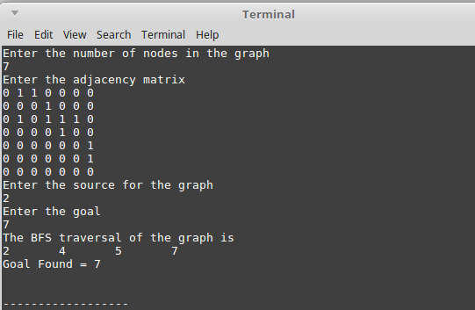
# CODE FOR DEPTH FIRST SEARCH :

import java.util.InputMismatchException;
import java.util.Scanner;
import java.util.Stack;
public class DFS
{
private Stack<Integer> stack;
public DFS()
{
stack = new Stack<Integer>();
}
public void dfs(int adjacency_matrix[][], int source)
{
int number_of_nodes = adjacency_matrix[source].length - 1;
int visited[] = new int[number_of_nodes + 1];
int element = source;
int i = source;
System.out.print(element + "\t");
visited[source] = 1;
stack.push(source);
while (!stack.isEmpty())
{
element = stack.peek();
i = element;
while (i <= number_of_nodes)
{
if (adjacency_matrix[element][i] == 1 && visited[i] == 0)
{
stack.push(i);
visited[i] = 1;
element = i;
i = 1;
System.out.print(element + "\t");
continue;
}
i++;
}
stack.pop();
}
}
public static void main(String...arg)
{
int number_of_nodes, source;
Scanner scanner = null;
try
{
System.out.println("Enter the number of nodes in the graph");
scanner = new Scanner(System.in);
number_of_nodes = scanner.nextInt();
int adjacency_matrix[][] = new int[number_of_nodes + 1][number_of_nodes + 1];
System.out.println("Enter the adjacency matrix");
for (int i = 1; i <= number_of_nodes; i++)
for (int j = 1; j <= number_of_nodes; j++)
adjacency_matrix[i][j] = scanner.nextInt();
System.out.println("Enter the source for the graph");
source = scanner.nextInt();
System.out.println("Enter the Goal ");
int a = scanner.nextInt();
System.out.println("The DFS Traversal for the graph is given by ");
DFS dfs = new DFS();
dfs.dfs(adjacency_matrix, source);
System.out.println("\nGoal is =" + a);

}catch(InputMismatchException inputMismatch)
{
System.out.println("Wrong Input format");
}
scanner.close();
}
}

************* OUTPUT ***********
